**Exercise**

* **write a program that asks the user to enter his/her name and greets them with “Hello <name>, has a good day” text.**

**Approach:**

**So here we did like this  
Take the name as an input**

**and print Hello first with user input**

**and concatenate with have a good day!**

**Solution 👇**

**Java :**

**import java.util.Scanner;**

**public class CodeXam {**

**public static void main(String[] args) {**

**System.*out*.println("What is your name");**

**Scanner sc = new Scanner(System.*in*);**

**String name = sc.next();**

**System.*out*.println("Hello " + name + " have a good day!");**

**}**

**}**

**output:**

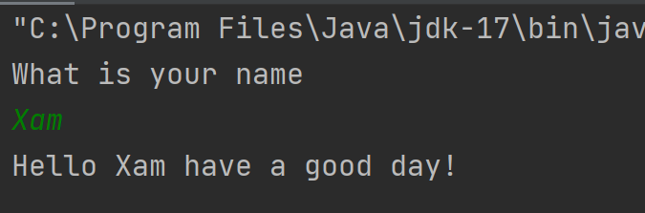

**Python :**

**name = input("What's your name ? \n")**

**print(f"Hello {name}, have a great day !")**

**output:**

